

**CONSOLIDATED REPORT**

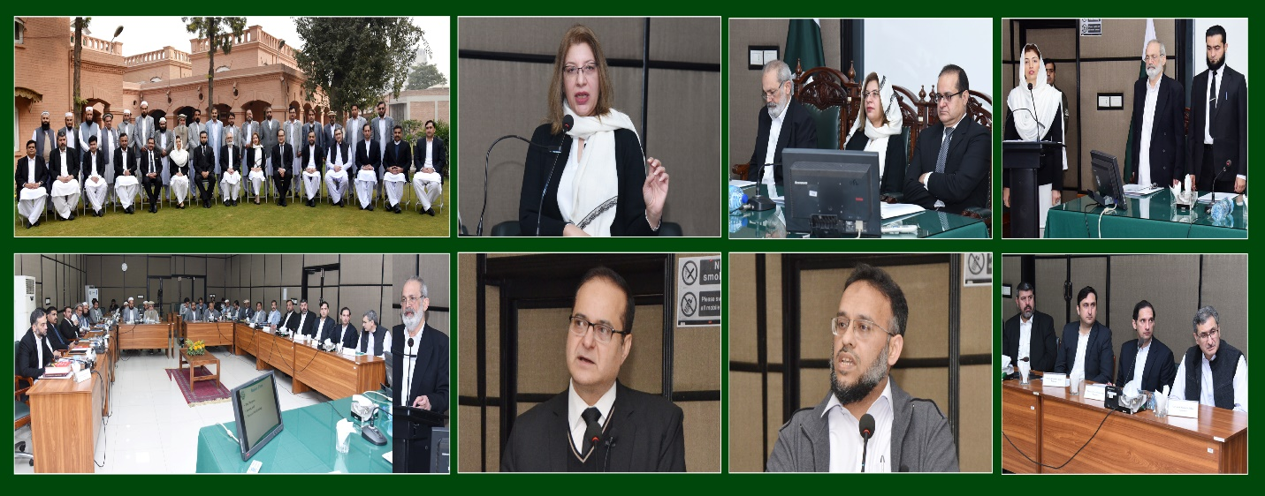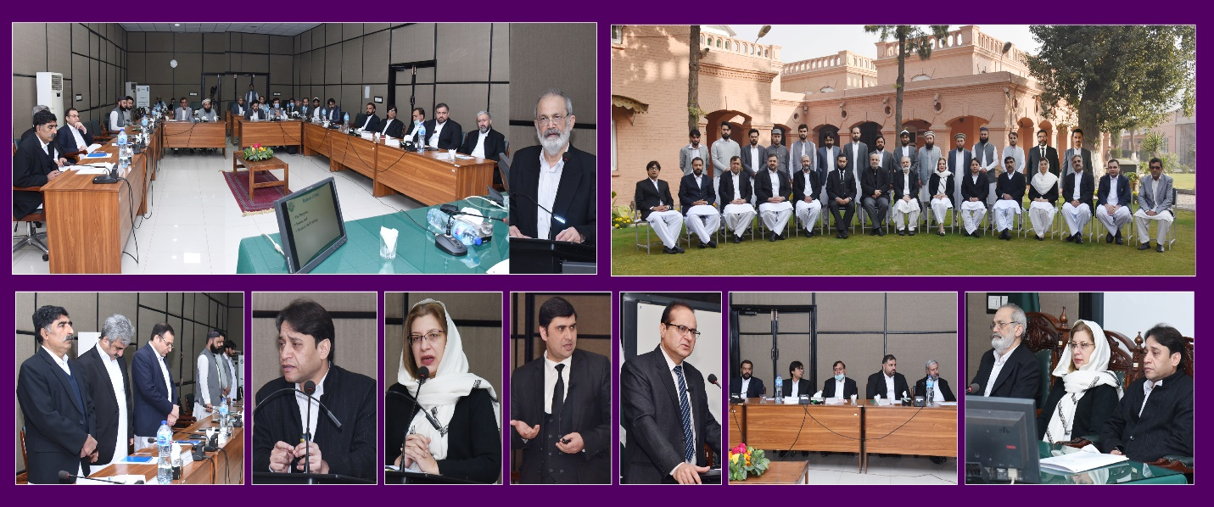**01-DAY TRAINING ON MAINTENANCE OF RECORD (PREPARATION, MAINTENANCE, TRANSMISSION & PRESERVATION OF JUDICIAL RECORD)**

**Prepared by:**Syed Yasir Shabbir (Director Instruction-I)

**Finalized by:**

Ms. Farah Jamshed (Dean Faculty)

**Composed by**:

Taimur Azam Khan (Assistant)

___________________________________________________________________________

Khyber Pakhtunkhwa Judicial Academy, Old Sessions Court Building, Jail Road, Peshawar

**Contents**

1.0 Introduction 1

2.0 Purpose of the report 1

3.0 Background 1

4.0 Participants 2

4.1 Batch-I: 2

4.1.1 List of Participants 2

4.1.2 Group Photo 4

4.2 Batch-II: 4

4.2.1 List of Participants 4

4.2.2 Group Photo 6

4.3 Batch-III: 6

4.3.1 List of Participants 6

4.3.2 Group Photo 7

4.4 Batch-IV: 7

4.4.1 List of Participants 7

4.4.2 Group Photo 8

4.5 Batch-V: 9

4.5.1 List of Participants 9

4.5.2 Group Photo 10

4.6 Batch-VI: 10

4.6.1 List of Participants 10

4.6.2 Group Photo 12

4.7 Batch-VII: 12

4.7.1 List of Participants 12

4.7.2 Group Photo 14

5.0 Schedule of Activities 14

6.0 Proceedings 15

7.0 Impact of the training 16

8.0 Quality of the training 17

9.0 Conclusion 19

# 

# 1.0 Introduction

1.1 The Khyber Pakhtunkhwa Judicial Academy is statutorily mandated to provide training to all justice sector stakeholders, to hold conferences, seminars, lectures, workshops and symposia in matters relating to court management, administration of justice, law and development of skills in legislative drafting and to establish liaison with research institutions, universities and other bodies including the Federal Judicial Academy, towards the cause of administration of justice (Section 4 of the Academy Act).

1.2 Capacity building in every field of judicial activity is a *sine qua non* for streamlining the system in its entirety. With this end in view, the Academy arranged seven consecutive 01- day trainings on Maintenance of Record for the District & Sessions Judges/ nominees, Senior Civil Judges (Judicial), Muharrars, Record Keepers, and In-charge of Copying Agency from all the Districts of the Khyber Pakhtunkhwa including the newly merged districts (NMDs).

# 2.0 Purpose of the report

2.1 This report aims to assess the quality and impact of the seven consecutive trainings rolled out between 15th & 30th November 2021 (both days inclusive).

2.2 The report begins with a general layout of the training sessions including training background, information about the participants, schedule of activities, proceedings and recommendations for future improvements.

# 3.0 Background

3.1 In the year 2020, for evaluation of the work of the Judicial Officers, an annual inspection was conducted by the Hon’ble Inspection Judges and the Principal Officers of the Peshawar High Court, Peshawar. Hon’ble the Chief Justice, Peshawar High Court, Peshawar was pleased to direct the principal officers, to sit with the Judicial Officers and conduct inspection in their presence also educating them to remove the deficiencies found in their courts and judicial work. Accordingly, the principal officers undertook a month-long hectic exercise and came up with their reports which were consolidated in the Annual Inspection Report 2020. The objective behind such inspection was to upgrade the standard of the district judiciary, especially to educate them thereby building their capacity.

3.2 The principal officers inspected the courts of Additional District &Sessions Judges, Senior Civil Judges, and Civil Judges/Judicial Magistrates and made assessments in accordance with already circulated proformas. They also observed some discrepancies. The judicial leadership instructed the Academy to devise a comprehensive module on Management of Judicial Record and to arrange trainings for capacity building of the District Judiciary.

3.3 The objectives, outcomes and the module of the program are as under:

3.4 **Objectives**

* To build capacity of the trainees for better management of judicial record;
* To sensitize them to the values of ethics and sense of self-accountability;
* To refine their professional skills for effective and efficient delivery of services;
* To motivate them towards exploring and utilizing tools for achievement of organizational targets; and
* To equip them with necessary skills.

3.6 **Learning Outcome**

* The trainees would be able to perform their duties with clarity, consistency, and confidence;
* They would be able to apply necessary skills and techniques for effective management of judicial record; and
* They would be able to improve their soft skills.

# 4.0 Participants

4.1 List of participants of the trainings along with their designations is as detailed below.

## 4.1 Batch-I:

### 4.1.1 List of Participants

|  |  |  |
| --- | --- | --- |
| DATED: 15 NOVEMBER 2021 | | |
| S.NO | NAME | DESIGNATION |
| 1 | Raja Muhammad Shoaib Khan | Additional District & Sessions Judge |
| 2 | Mr. Abid Zaman | Additional District & Sessions Judge |
| 3 | Mr. Khalid Mansoor | Senior Civil Judge |
| 4 | Mr. Shaukat Ali | Senior Civil Judge |
| 5 | Mr. Fazal Nasir Shah | Senior Civil Judge |
| 6 | Mr. Muhammad Hanif | Senior Civil Judge |
| 7 | Ms. Kiran Shaukat | Senior Civil Judge |
| 8 | Ms. Tania Hashmi | Senior Civil Judge |
| 9 | Mr. Muhammad Sher Ali khan | Senior Civil Judge |
| 10 | Mr. Rahamdad Khan | Superintendent |
| 11 | Mr. Riaz Muhammad | Assistant |
| 12 | Mr. Israr Jehan | Assistant |
| 13 | Mr. Parvez Muhammad | Assistant |
| 14 | Mr. Said ul Naeem | Assistant |
| 15 | Mr. Muhammad Sareer | Assistant |
| 16 | Mr. Shahid Ali | Assistant |
| 17 | Mr. Sufaid Gul | Senior Clerk |
| 18 | Mr. Muhammad Ismail khan | Senior Clerk |
| 19 | Mr. Manzoor Khan | Naib Nazir |
| 20 | Mr. Muhammad Anwar | Junior clerk |
| 21 | Mr. Farhad Ali | Junior clerk |
| 22 | Mr. Rehan Ullah | Muharrar /JC |
| 23 | Mr. Zubair Alam | Junior Clerk |
| 24 | Mr. Zahir Khan | Junior Clerk |
| 25 | Syed Ahtizaz Ali Shah | Junior Clerk |
| 26 | Mr. Alamgeer Hayat | Junior Clerk |
| 27 | Mr. Muhammad Salman Khan | Junior Clerk |
| 28 | Mr. Mr. Muhammad Bilal | Junior Clerk |
| 29 | Syed Ghaws Ali Shah | Senior Clerk |
| 30 | Mr. Sartaj Muhammad | Junior Clerk |
| 31 | Syed Hamid Shah | Junior Clerk |
| 32 | Mr. Abdul Haseeb | Junior Clerk |
| 33 | Mr. Aftab Ahmad | Junior clerk |
| 34 | Mr. Hidayat Ullah | Junior Clerk |
| 35 | Mr. Abid Jan | Junior Clerk |

### 4.1.2 Group Photo

## 

## 4.2 Batch-II:

### 4.2.1 List of Participants

|  |  |  |
| --- | --- | --- |
| Dated: 17th November 2021 | | |
| S.NO | NAME | DESIGNATION |
| 1 | Mr. Abdul Ghafoor Qureshi | District & Sessions Judge |
| 2 | Ms. Phool Bibi | District & Sessions Judge |
| 3 | Ms. Rashida Bano | District & Sessions Judge |
| 4 | Mr. Tilla Muhammad | Additional District & Sessions Judge |
| 5 | Ms. Nadia Gul Wazir | Senior Civil Judge |
| 6 | Mr. Hussain Ali | Senior Civil Judge |
| 7 | Mr. Akbar Ali | Senior Civil Judge |
| 8 | Mr. Asif Kamal | Senior Civil Judge |
| 9 | Ms. SairaBano | Senior Civil Judge |
| 10 | Mr. Sohrab Ahmad | Civil Judge |
| 11 | Mr. Naveed Ur Rehman | Senior Clerk |
| 12 | Mr. Shahid Mehmood | Senior Clerk |
| 13 | Mr. Abubakar Kamran | Senior Clerk |
| 14 | Mr. Muhammad Naeem | Senior Clerk |
| 15 | Mr. Said Wahid Shah | Senior Clerk |
| 16 | Mr. Iqbaluddin | Senior Clerk |
| 17 | Syed Ejaz Hussain | Junior Clerk |
| 18 | Mr. Naeem Afridi | Junior Clerk |
| 19 | Mr. Gul Bacha | Junior Clerk |
| 20 | Mr. Rahimullah | Junior Clerk |
| 21 | Mr. Farasat Ullah | Junior Clerk |
| 22 | Mr. Shah Rawan | Junior Clerk |
| 23 | Mr. Nadeem Ahmad | Junior Clerk |
| 24 | Mr.Sher Ahmad Khan | Junior Clerk |
| 25 | Mr. Noor Akbar Shah | Junior Clerk |
| 26 | Mr. Jaghfar Ali | Junior Clerk |
| 27 | Mr. Khalil Ur Rehman | Junior Clerk |
| 28 | Mr. NaveedAlam | Junior Clerk |
| 29 | Mr. Abdul Haleem | Junior Clerk |
| 30 | Mr. Abdul Jalal | Junior Clerk |

### 4.2.2 Group Photo

## 4.3 Batch-III:

### 4.3.1 List of Participants

|  |  |  |
| --- | --- | --- |
| DATED: 20th NOVEMBER 2021 | | |
|  | | |
| S.NO | NAME | DESIGNATION |
| 1 | Mr. Suhail Sheraz Noor Saani | District & Sessions Judge |
| 2 | Mr. Wali Muhammad Khan | Additional District & Sessions Judge |
| 3 | Mr. Adil Zeb Khan | Additional District & Sessions Judge |
| 4 | Ms. Shamsul Huda | Senior Civil Judge |
| 5 | Ms. Qurat- ul-Ain Chand Irfan | Senior Civil Judge |
| 6 | Ms. ImranaShaheen | Senior Civil Judge |
| 7 | Mr. SherazFirdos | Senior Civil Judge |
| 8 | Mr. Ilyas Saeed | Civil Judge |
| 9 | Mr. Muhammad Naseer | Senior Clerk |
| 10 | Sijjad Riaz | Senior Clerk |
| 11 | Mr.Bakhtiar | Muharrir |
| 12 | Mr. Faiz Muhammad | Record Keeper |
| 13 | Mr. Muhammad Zuqaib Iqbal Khan | Record Keeper |
| 14 | Mr. Muhammad Qasim | Record Keeper |
| 15 | Mr. Sher Bahader | Copyist |
| 16 | Mr. Iftikhar Ahmad | Junior Clerk |
| 17 | Mr. Nazir Ahmad | Junior Clerk |
| 18 | Mr. Maqsood Elahi | Junior Clerk |
| 19 | Mr. Muhammad Riaz | Junior Clerk |
| 20 | Mr. Zaheer Ullah Khan | Junior Clerk |
| 21 | Mr. Muhammad Saqib | Junior Clerk |
| 22 | Mr. Saeed ur Rehman | Junior Clerk |

### 4.3.2 Group Photo

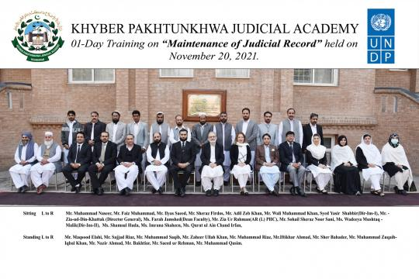

## 4.4 Batch-IV:

### 4.4.1 List of Participants

|  |  |  |
| --- | --- | --- |
| DATED: 22nd NOVEMBER 2021 | | |
| S.NO | NAME | DESIGNATION |
| 1 | Mr. Muhammad Nasim | District & Sessions Judge |
| 2 | Mr. Shaukat Ahmad Khan | District & Sessions Judge |
| 3 | Mr. Abdul Jabbar | District & Sessions Judge |
| 4 | Mr. Ihsan ul Haq | Additional District & Sessions Judge |
| 5 | Mr. Farman Ullah | Senior Civil Judge |
| 6 | Syed Israr Ali Shah | Senior Civil Judge |
| 7 | Mr. Najeeb- ul- Haq | Senior Civil Judge |
| 8 | Mr. Imranullah | Senior Civil Judge |
| 9 | Mr. Hidayat Ullah | Senior Clerk |
| 10 | Syed Ameer Shah Raza | Senior Clerk |
| 11 | Mr. Shirkat Ali | Senior Clerk |
| 12 | Mr. Rafiullah | Junior Clerk |
| 13 | Mr. Abdul Munaiem | Junior Clerk |
| 14 | Mr. Najeeb Ullah | Junior Clerk |
| 15 | Mr. Muhammad Ajmal | Junior Clerk |
| 16 | Mr. Khurshid Ali | Junior Clerk |
| 17 | Mr. Fazal Haq | Junior Clerk |
| 18 | Mr. Asif Samad | Junior Clerk |
| 19 | Mr. Amanullah | Junior Clerk |
| 20 | Mr. Dost Muhammad | Junior Clerk |
| 21 | Mr. Fazal Hadi | Junior Clerk |
| 22 | Mr. Saddam Khan | Junior Clerk |
| 23 | Mr. Navid Khan | Junior Clerk |
| 24 | Mir Hussain | Court Staff |

### 

### 4.4.2 Group Photo

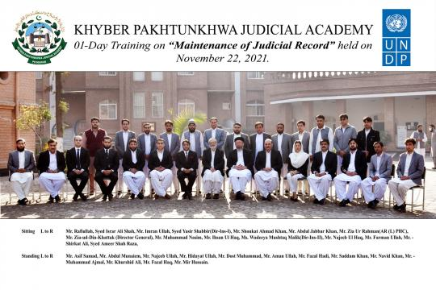

## 4.5 Batch-V:

### 4.5.1 List of Participants

|  |  |  |
| --- | --- | --- |
| DATED: 24th NOVEMBER 2021 | | |
| S.NO | NAME | DESIGNATION |
| 1 | Mr. Muhammad Shoaib | District & Sessions Judge |
| 2 | Mr. Wajid Ali Khan | Additional District & Sessions Judge |
| 3 | Syed Murad Ali Shah | Additional District & Sessions Judge |
| 4 | Mr. Muhammad Ilyas Khan | Senior civil judge |
| 5 | Mr. Hamid Kamal | Senior civil judge |
| 6 | Mr. Muhammad Jamshed Kundi | Senior civil judge |
| 7 | Mr. Abdul Salam khan | Senior civil judge |
| 8 | Mr. Nadeem Akhtar | Senior civil judge |
| 9 | Mr. Iftikhar Ahmed | Senior civil judge |
| 10 | Mr. Muhammad Adil Misal | Civil judge |
| 11 | Mr. Muhammad Rashid Khan | Superintendent |
| 12 | Mr. Aziz Ullah | Assistant |
| 13 | Mr. Noor Alamin | Muharrir |
| 14 | Mr. Zubair Shah | Muharrir |
| 15 | Mr. Ihsan Ul Haque | Muharrir |
| 16 | Mr. Muhammad Rafiq Kundi | Muharrir |
| 17 | Mr. Bakhtyar Ali | Muharrir |
| 18 | Mr. Shakir Ullah | Muharrir |
| 19 | Mr. Saeed Ur Rahman | Muharrir |
| 20 | Mr. Rahman Ullah | Incharge Copying Branch |
| 21 | Mr. Mohammad Sohail | Record Keeper |
| 22 | Mr. Khwaja Sahib | Muharrir |
| 23 | Mr. Izzat Gul | Senior Clerk |
| 24 | Mr. Rehman Ali | Record Keeper |
| 25 | Mr. Asghar Khan | Record keeper |
| 26 | Mr. Ghulam Daud | Record keeper |
| 27 | Mr. Rehan Ali | Record Keeper |
| 28 | Mr. Muhammad Riaz | CopistIncharge |
| 29 | Abdul Dayan | Reader |

### 4.5.2 Group Photo

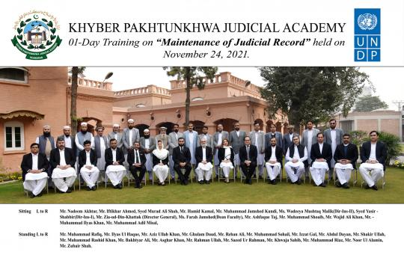

## 

## 4.6 Batch-VI:

### 4.6.1 List of Participants

|  |  |  |
| --- | --- | --- |
| DATED: 27th NOVEMBER 2021 | | |
| S.NO | **NAME** | **DESIGNATION** |
| 1 | Mr. Shafiq Ahmad Tanoli | District & Sessions Judge |
| 2 | Ms. Muneera Abbasi | District & Sessions Judge |
| 3 | Ms. Hajira Rehman | District & Sessions Judge |
| 4 | Ms. Shabana Mehsood | Additional District & Sessions Judge |
| 5 | Mr. Abdul Basit | Additional District & Sessions Judge |
| 6 | Mr. Fazal Gul | Additional District & Sessions Judge |
| 7 | Ms.Sidra Azmat | Senior Civil Judge |
| 8 | Mr. Ijaz Younas | Senior Civil Judge |
| 9 | Syed Mansoor Shah Bukhari | Senior Civil Judge |
| 10 | Mr. Shah Faisal | Senior Civil Judge |
| 11 | Mr. Bakhtzada | Senior Civil Judge |
| 12 | Mr. Irshad Hussain | Assistant |
| 13 | Mr. Muhammad Saleem | Assistant |
| 14 | Mr. Tariq Khan | Muharrir |
| 15 | Mr. Muhammad Ibrahim | Muharrir |
| 16 | Mr. Samiullah Khan | Muharrir |
| 17 | Mr. Ghulam Rasool | Muharrir |
| 18 | Mr. Nisar Ahmad | Muharrir |
| 19 | Mr. Ajab Khan | Senior Clerk |
| 20 | Mr. Rahmatullah | Reader |
| 21 | Mr. Abdul Kareem | Record Keeper |
| 22 | Hafiz Latif ur Rehman | Record Keeper |
| 23 | Mr. Bilal Ahmad | Computer Operator |
| 24 | Mr. Muhammad Sulaiman | Examiner |
| 25 | Mr. Arif Mehmood | Junior Clerk |
| 26 | Mr. Muhammad Sher | Junior Clerk |
| 27 | Mr. Khalid Rehman | Junior Clerk |
| 28 | Mr. Amin Ali | Junior Clerk |
| 29 | Mr. Muhammad Haroon Khan | Junior Clerk |
| 30 | Mr. Jahad Ullah | Junior Clerk |
| 31 | Mr. Majid Khan | Junior Clerk |
| 32 | Mr. Karim Ali | Junior Clerk |

### 4.6.2 Group Photo

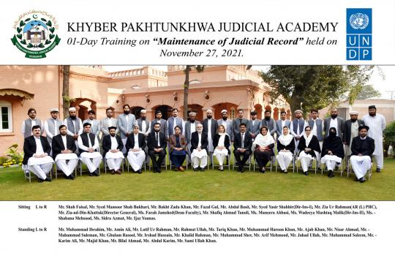

## 

## 4.7 Batch-VII:

### 4.7.1 List of Participants

|  |  |  |
| --- | --- | --- |
| DATED: 30th NOVEMBER 2021 | | |
| S.NO | NAME | DESIGNATION |
| 1 | Syed Aqeel Ajiz | District & Sessions Judge |
| 2 | Mr. Shah Waliullah Hamid | District & Sessions Judge |
| 3 | Syed Zahid Shah | Additional District & Sessions Judge |
| 4 | Mr. Fida Muhammad | Additional District & Sessions Judge |
| 5 | Mr. Asmatullah Wazir | Additional District & Sessions Judge |
| 6 | Mr. Islamuddin | Senior Civil Judge |
| 7 | Mr. Muhammad Shoaib | Senior Civil Judge |
| 8 | Mr. Arshad Khan Afridi | Senior Civil Judge |
| 9 | Mr. Muhammad Rehan Samad | Senior Civil Judge |
| 10 | Mr. Inayat ur Rehman | Senior Clerk |
| 11 | Mr. Umar Daraz | Senior Clerk |
| 12 | Mr. Mukhtiar Ahmed | Senior Clerk |
| 13 | Mr. Asfandyar Ahmad | Junior Clerk |
| 14 | Mr. Azmat Ullah Khan | Junior Clerk |
| 15 | Mr. Alam Dad | Junior Clerk |
| 16 | Mr. Irfan Khan | Junior Clerk |
| 17 | Mr. Waleed Ahmad | Junior Clerk |
| 18 | Mr. Muhammad Qasim | Junior Clerk |
| 19 | Mr. Tanzilur Rehman | Junior Clerk |
| 20 | Mr. Ahmad Hussain | Junior Clerk |
| 21 | Mr. Sami Ullah | Computer Operator |
| 22 | Mr. Maqbool Rehman | Incharge Copy Branch |
| 23 | Mr. Naveed Alam | Record Clerk |
| 24 | Mr. Sharif Ullah | Reader |

### 4.7.2 Group Photo

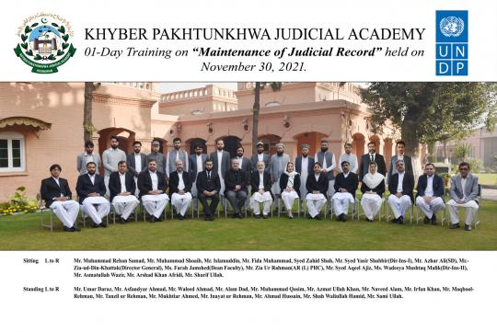

# 5.0 Schedule of Activities

5.1 Schedule of Activities is detailed as: -

|  |  |  |  |  |  |  |  |
| --- | --- | --- | --- | --- | --- | --- | --- |
| SCHEDULE OF ACTIVITIES | | | | | | | |
| Batch-I:  Batch -II: Batch -III: Batch -IV: | | | 15th November 2021,  17th November 2021,  20th November 2021,  22nd November 2021, | **Batch -V:**  **Batch -VI:**  **Batch -VII:** | | 24th November 2021,  27th November 2021, and  30th November 2021. | |
|  | | | | | | | |
| S.# | **Activities** | | | | **Resource Person** | | **Duration** |
| 1.1 | **Inaugural Ceremony**   * Registration & Pre-Evaluation * Recitation from the Holy Quran * National Anthem | | | |  | | 08:30-09:00 |
| 1.2 | **Welcome Address / Orientation** | | | | Director General | | 09:00-09:10 |
| 1.3 | **Group Photo** | | | |  | | 09:10-09:15 |
| 1.4 | **Preparation and Maintenance of Judicial Record**   * Index * Decree sheet * Registers to be maintained * Arrangement of Civil & Criminal Records (Part-A and Part-B) * Consignment * Inspection | | | | Mr. Zia Ur Rehman D&SJ/Additional Registrar (Legl), PHC/ Mr. Ashfaque Taj, District & Sessions Judge,Peshawar | | 09:15-10:45 |
|  | ***Tea Break 10:45 - 11:15*** | | | | | | |
| 1.5 | **Custody and Transmission of Judicial Record**   * Pending Cases * Mode of Transmission * Precepts of High Court | | | | Mr. Ashfaque Taj, District & Sessions Judge,Peshawar | | 11:15-12:45 |
| *Prayer & Lunch 12:45 - 01:30* | | | | | | | |
| 1.6 | **Preservation essential and weeding out of unnecessary Record**   * Judicial Record * Registers | | | | Mr. Ahmad Iftikhar, D&SJ/ Mr. Zaeem Ahmed, Director (HRW), SDJ, PHC | | 01:30- 02:30 |
| 2.4 | | **Concluding Ceremony**   * Post Training Evaluation * Class Representative Remarks * Wrap up / Certificate Distribution | | |  | | 02:30  Onwards |

**6.0 Proceedings**

6.1 **Registration and Pre-Evaluation**: Before formal commencement of the activities, registration of the participants and their pre-training evaluations were conducted..

6.2 **Inaugural Ceremony**: All trainings commenced with an inaugural ceremony chaired by Mr. Zia-ud-Din Khattak, Director General, Khyber Pakhtunkhwa Judicial Academy. In his address, the Director-General extended a welcome to the participants. He congratulated them upon their selection for this course. He also offered special thanks to the resource persons for sparing time out of their busy schedules and coming to the Academy for discourse. He briefly explained the background of the training besides its objectives and learning outcome. He advised the participants to make every effort for gainful utilization of training time and go well equipped with adequate knowledge, information, and tools for the performance of their duties.

**6.3** **Lectures Synopsis**

6.3.1 Mr. Zia-ur-Rehman D&SJ/Additional Registrar (Legal), PHC, and Mr. Ashfaque Taj, District & Sessions Judge, Peshawar, spoke on “Preparation and Maintenance of Judicial Record” in the light of High Court Rules & Orders and Standing Orders of the Judicial Commissioner, NWFP (KPK), which contain directions to maintain (printed) registers for different purposes. Both learned speakers referred to the subject of ‘maintenance of record’ as the most neglected area and remarked that non-observance of the prescribed rules has led to irremediable consequences in the shape of piling of unorganized bulk in the Record Room. The speakers emphasized the importance of effective record management and pinpointed the role and responsibilities of judges and court staff in this regard. The Resource Persons observed that “the ultimate test of a good record maintenance program is whether the records are available to those who need them, when and where they are needed (Effectiveness), the manner in which they are made available (Efficiency), and at what cost (Economy)”.

6.3.2 Mr. Ashfaque Taj, District & Sessions Judge, Peshawar also delivered lectures on ‘Custody and Transmission of Judicial Record’. He extensively focused on the High Court Rules and precepts on the transmission of Judicial records. Practical examples also formed part of the presentation. The lecture ended with a Q&A session.

6.3.3 Mr. Ahmad Iftikhar, District & Sessions Judge, Khyber, and Mr. Zaeem Ahmed, Director (HRW), SDJ, Peshawar High Court, Peshawar, gave detailed presentations on “Preservation of Essential and Weeding Out of Unnecessary Record.” Their lectures included practical exercises that illustrated preservation of the necessary and weeding out of unnecessary records.

6.4 **Post-Evaluation:** On the last day of the training, the post-training evaluation of each batch was conducted.

6.**5 Concluding Ceremony**: Each training concluded with a concluding ceremony presided over by the Director General; the class representative shared his/her views and appreciated the efforts made by the Academy. In the end, the Director General awarded certificates to the participants.

# 7.0 Impact of the training

7.1 Significant indicator of the training impact is:

7.1.1 Whether the training contributed to an increase in the knowledge of the participants?

7.1.2 Whether that will translate itself into a practical utility?

The pre & post-evaluation questionnaire was designed to deal with this aspect. The relevant feedback obtained from the participants is reflected below:

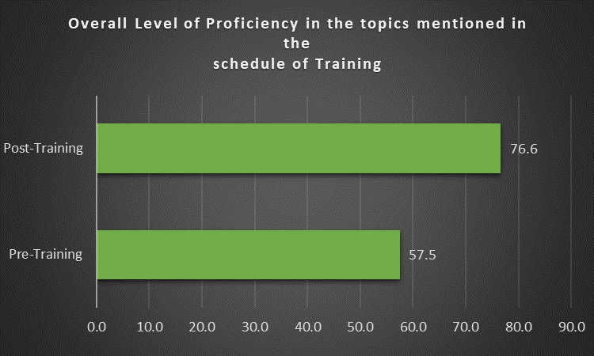

# 8.0 Quality of the training

8.1 The quality of the training can be assessed by the participants’ evaluation of the resource persons. Moreover, the participants were asked to comment on the overall quality of the training program. Their response and the feedback are shown in graphic form below:

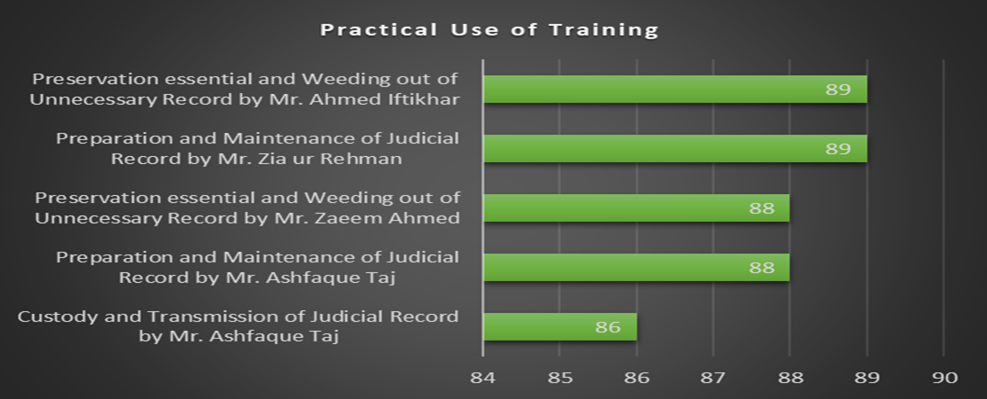

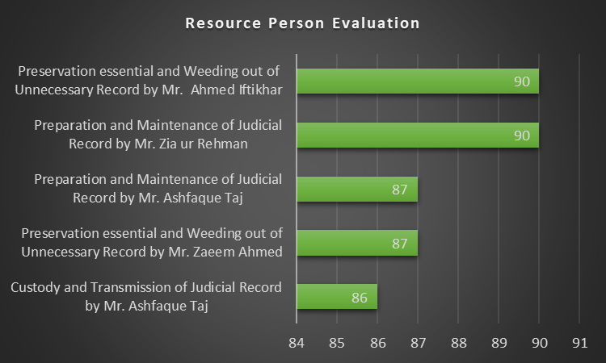

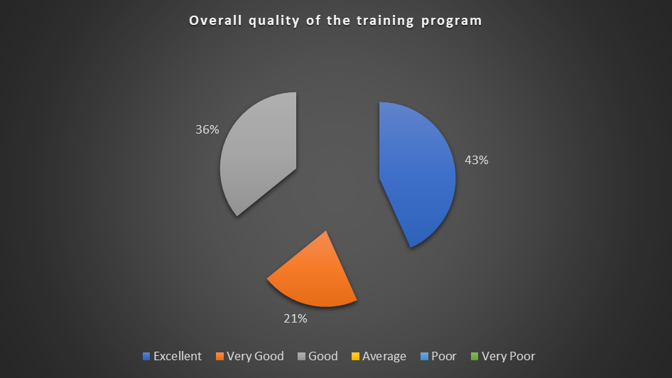

8.2 Participants also furnished their general comments on the training and the same as summarized by the class representatives are as follows:

1. Participants appreciated the efforts of KPJA.
2. Overall trainings were comprehensive.
3. The trainings may be periodically arranged to enhance the capacity of District Judiciary.
4. Training duration may be enhanced to at least 3 to 5 days.
5. Special attention may be given to NMDs.
6. Training material should be circulated via email or its link should be shared with the participants in advance.
7. Local training should be arranged for the district courts and the court officials should be facilitated.

# 

# 9.0 Conclusion

9.1 Participants' graphical feedback indicates that the training's performance and effect have been rated very good.

9.2. Based on the participants' feedback, training modules can be further improved.

9.3. The trainees review reflects the achievement of training objectives.